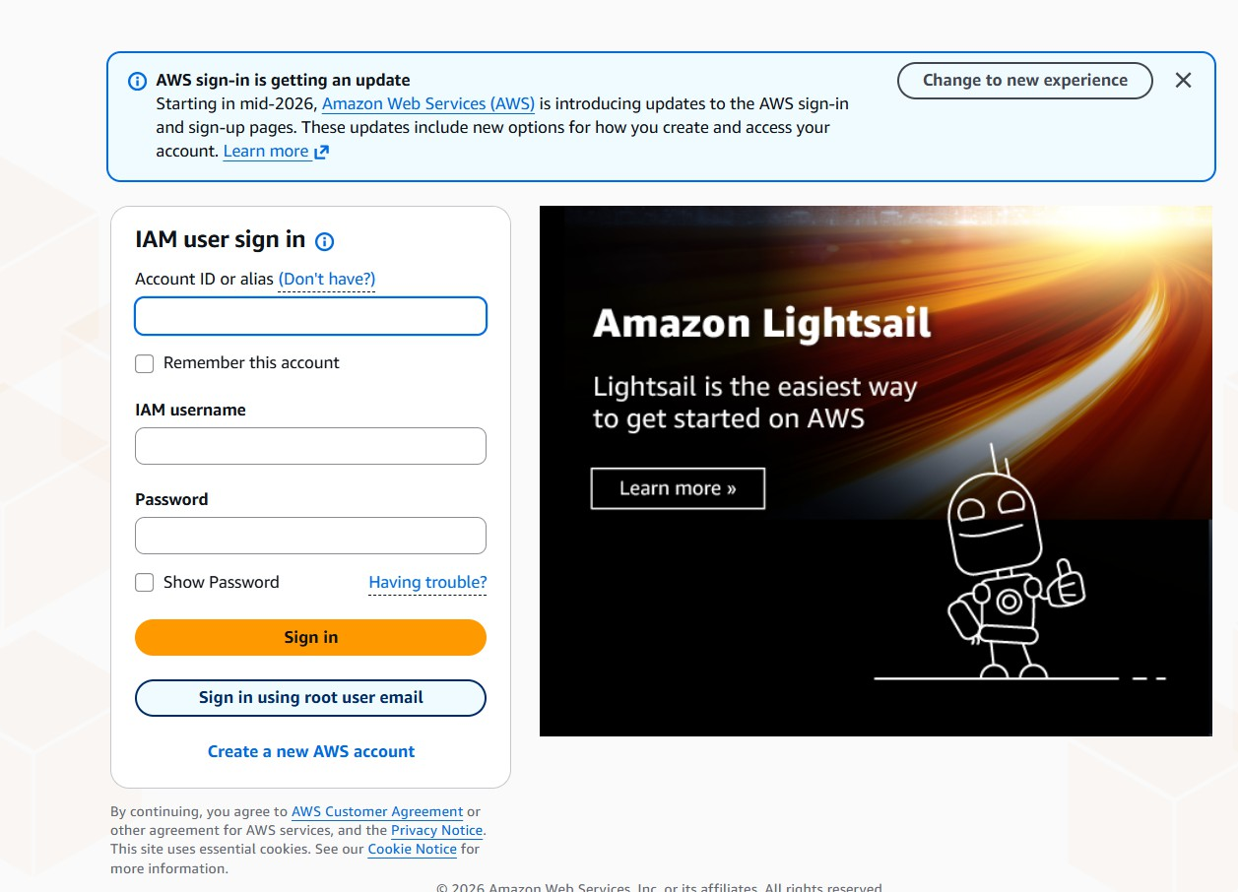
MFA(SKILL-2)

- NOW SIGN IN USING ROOT USER EMAIL

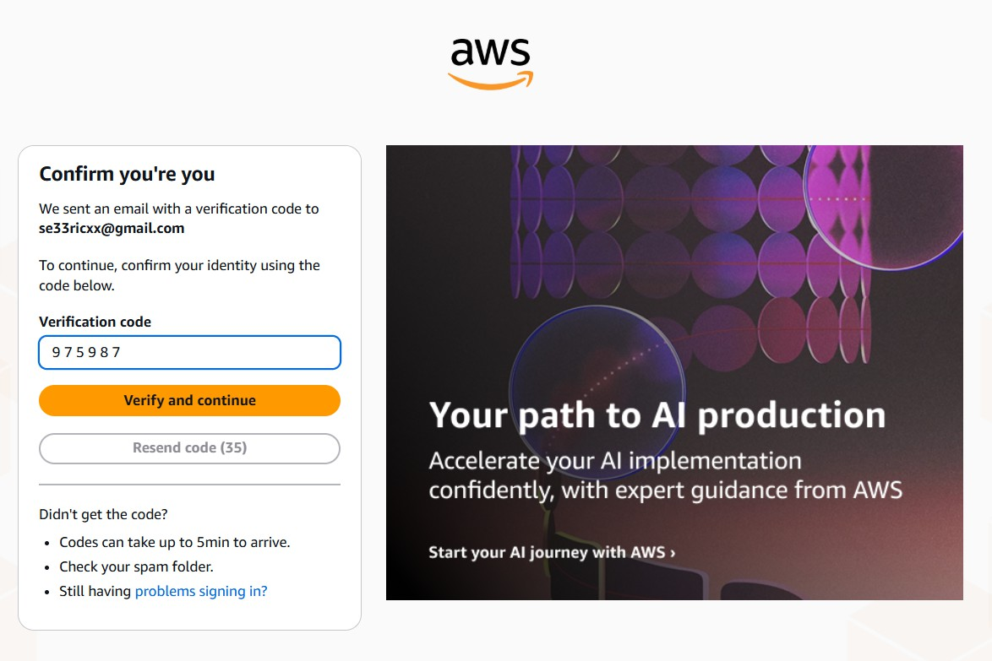
- VERIFY

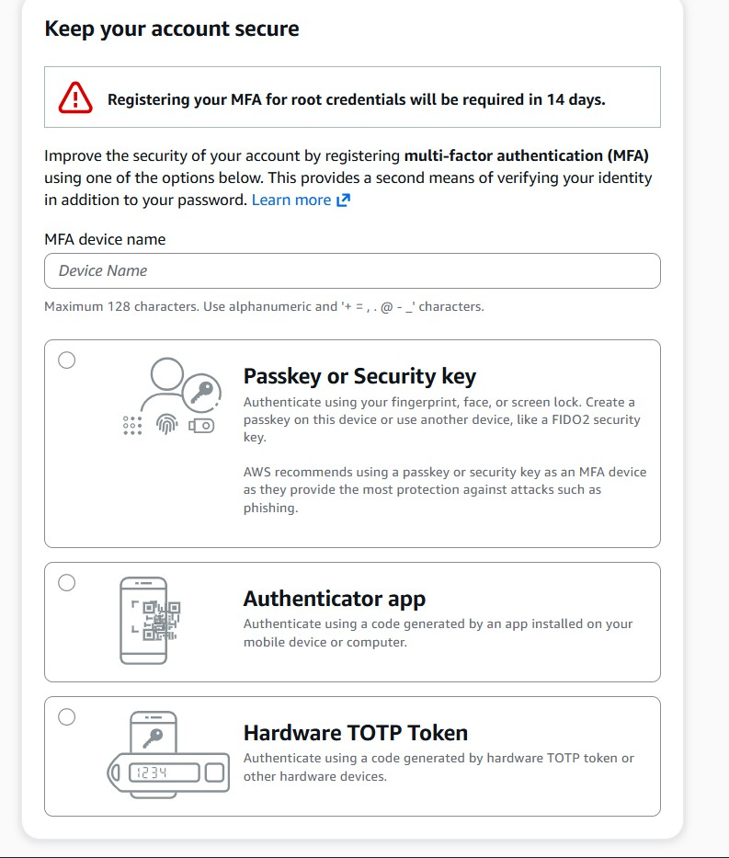
- CHOOSE AUTHENTICATOR APP

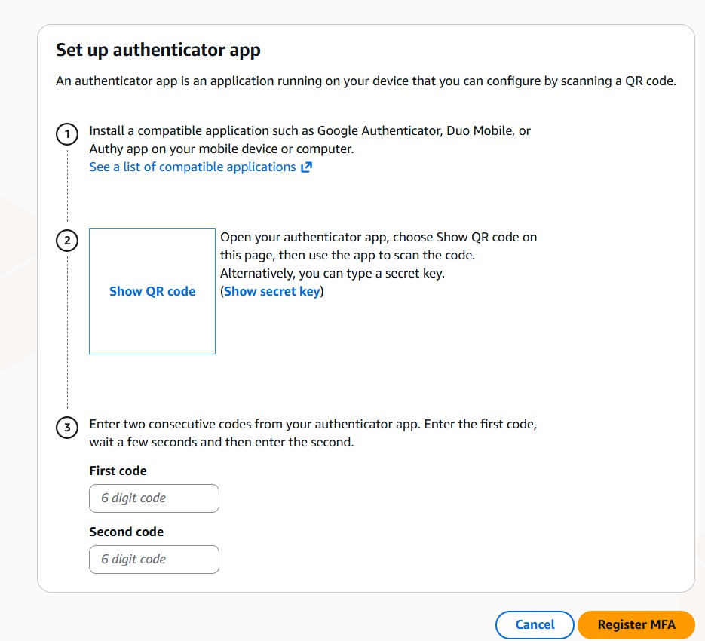
- SHOW QR CODE AND GENERATE TWO CODES AND REGISTER

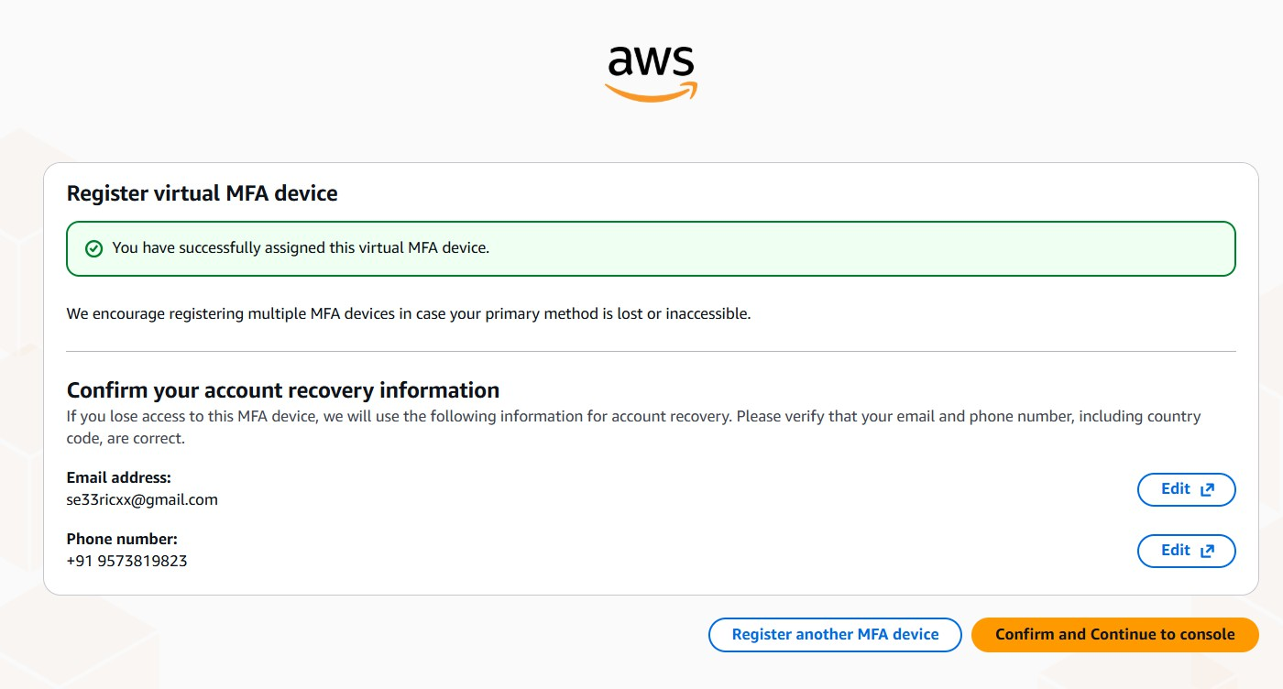
- SUCCESSFUL REGISTRATION

